NWAIWU FRANCISCA UCHECHUKWU
DATA ANALYSIS PORTFOLIO
DATA DRIVEN INSIGHTS ,SQL ANALYSIS/DATA VISUALIZATION
27 SEPTEMBER 2026

DATA ANALYSIS PORTFOLIO REPORT
PERSONAL SKILL SUMMARY:
A results driven junior data analyst, aspiring to endeavour in action oriented business analysis, passionate and dedicated to continuous learning, career evolution and sharpening my data skillset to enrich businesses by uncovering key business insights and translating complex metrics into clear, actionable business strategies.
PROFESSIONAL BACKGROUND:
Prior to writing a single line of SQL, I was already working with data every day, I just did not realize I was already thinking like an analyst, gathering information and spotting patterns. My professional background started at Federal Polytechnic Oko, Anambra State, Nigeria where I secured a higher national diploma in public administration.
During my industrial training, I assumed a leadership position as a warehouse manager overseeing a team of 4 at Josefranca’s global links, Aba, Abia state in 2020. I managed warehouse inventories, ensuring accurate stock levels, efficiency and timeliness, supervised and coordinated warehouse staff to optimize workflow, conducted control checks to minimize errors and prevent stock discrepancies.
I oversaw order fulfilment, responded to inquiries and resolved customer concerns, maintained detailed records of inventory transactions, prepared reports for management and understands the unending importance of data integrity as a missing inventory data impact the bottom line.
Later, I worked as a sales representative at Double blessed confectioneries, Aba, Abia State where I monitored sales pipelines, identified market trends and customer purchase patterns. At present, I am a teacher and teaching involves data translation. I design data based lessons, explain topics and use data driven instructions to identify areas for improvement.
I track pupil’s performance, identify learning gaps using test scores, modify instructional plans accordingly and adjusts curriculum strategies based on data points. These backgrounds has a laid a great foundation and inculcated in me the vital business acumen needed to build impactful executive dashboards.
Now, I am building on that background with technical skills to back it up – SQL, data visualization, statistical analysis. This portfolio is where the experience meets the tools. I am early in my data analysis journey but brings years of real world operational experience with me. I am looking for a company willing to invest in that combination as I am committed to invest. If my background fits with what your team is building, I would welcome the opportunity to explore how I can add value.

TABLE OF CONTENTS:
1. PROFESSIONAL BACKGROUND……………………………………………………………….1
2. INTRODUCTION…………………………………………………………………………………….. 3
3. KEY DATA QUALITY NOTES…………………………………………………………………….. 3
4. ROOT CAUSE ANALYSIS PROCESS ……………………………………………………………6
5. INSIGHTS FROM ANALYSIS……………………………………………………………………… 6
6. VISUALIZATINS……………………………………………………………………………………….16
7. RECOMMENDATION ..................................................................................22
8. CONCLUSION .............................................................................................23
9. APPENDIX…………………………………………………………………………………………….…23

INTRODUCTION:
I am a junior data analyst recently hired at GLOBAL SUPERSTORE, an international retail giant. During the annual executive financial review, the chief financial officer highlighted a gap in all time high revenue with low actual profit. The VP of logistics reported that shipping department is overwhelmed and customer service is dealing with a massive spike in project returns. With organizational data spread across four different tables, I am to stitch the tables together and extract truth from the operational tables to reveal what is happening beneath the numbers.
THE CORE BUSINESS PROBLEM:
Global Superstore is generating high revenue, but suffering from shrinking profit margins, inefficient discount strategies, and undocumented logistical bottlenecks. Because the data is separated into Customers, Products, Locations and Orders tables, the business is operating on assumptions rather than consolidated data.

OBJECTIVE OF THE AUDIT:
- Financial & Product Audit: Identify the disconnect between high sales and low profitability by evaluating product categories, discount impacts, and baseline transaction metrics using multi-table SQL joins.
- Customer Retention & Logistics Optimization: Segment the most valuable customers for VIP marketing, audit shipping efficiencies, and quantify the financial damage caused by loss-making orders.
ABOUT THE DATASET:
The dataset provided is a global transaction-level export covering order_date range 2011–2014, comprising 51,290 rows and 26 columns. The details includes customer, Product, Location, and Order-levels across seven world markets (US, EU, LATAM, Africa, APAC, EMEA, and Canada).
KEY FEATURES OF THE DATASET:
- 51,290 individual transaction records (Rows)
- 4,873 unique customers
- 10,292 unique products
- Fields include sales, profit, discount, quantity, Shipping_cost, Ship_mode, order_Priority, region, state, segment, and more.
KEY DATA QUALITY NOTES:
- PRODUCT_ID: Discovered that product_id is not a reliable unique identifier in this dataset – 476 instances tied to 457 rows shares product-Ids across distinct products. E.g Dana classic bookcase vs Sauder corner shelving both under FUR-BO-10000087. This affected 4,392 order lines (8.6% of the dataset) inflating SUM(sales) and SUM(profit) for the affected categories and sub_categories , large enough to distort the results of Q9 and Q10 if left uncorrected.
- CORRECTIVE ACTION-DEDUPLICATION
The product table was de-duplicated to one row per product_id prior to joining it against the order table for Q9 and Q10, category was unaffected by this choice but the sub_category was affected in exactly one case(OFF-AVE-10002102) which was reviewed manually. The original product table was left unaltered; product clean was used only where row multiplication would otherwise distort aggregation (Q9 and Q10).
An unaddressed join on product id inflated tables reported sales and overstated it’s net loss- concrete evidence that skipping the deduplication step would have distorted Q9 accuracy.
 | SALES(RAW JOIN) | SALES (CORRECTED JOIN) | PROFIT (RAW JOIN) | PROFIT(CORRECTED)  JOIN
TABLES | 836075 | 757034 | -72115.3993 | -64083.3887

- CUSTOMER_ID: While validating customer integrity, I observed that of 4,873 unique customer_ids, only 795 unique customer_names were found. This means that some names are shared by multiple customers as expected in a global customer base and was confirmed to be a non-issue as each customer_id maps to exactly one customer_name confirming customer_id a reliable unique identifier.
- ORDER ID: 660 distinct order_ids were found reused across different customers and order-dates (717 total duplicate instances), affecting 2,703 order lines (5.3% of the dataset) 2,701 rows involved in customers mismatch and 2,699 rows involved in order_date mismatch with overlap between the two, investigated and confirmed to have no impact on audit.
- LOCATION JOIN(STATE/REGION: The locations table contained multiple rows per state, causing a join fan out when added to orders on state alone inflating sales totals for some states. Since the orders table has only state, no city or country, the locations table was deduplicated to 1 row per state before joining. Some state name maps to more than one region globally e.g southern, central. For this one region was selected via MIN(). See below APPENDIX
Minor note: Location_clean contains 1,093 rows instead of the expected 1,094 due to a case sensitivity merge in state values. This state does not affect sales aggregation, since MYQSL’s default matching is also case sensitive.

- PRODUCT TABLE-COLUMN-SHIFT: (52 rows)
A significant issue, was found while checking sub-category values for validity, 52 rows in the products table contained values that did not match any of the 17 real sub_categories (e.g “1040 sheets”, “black”, “200/ messages”). Investigation traced this to a C.S.V import parsing bug- product_names containing doubled inch-mark quotation characters (e.g 51/42””) confused the import parser’s quote tracking , shifting each affected row’s true category one column to the right into sub_category , while a fragment of the product_name spilled into the category field. The true sub_category for each affected row was lost from the row entirely, absorbed into the product_name text.

SQL CODE:
SELECT Product_ID, Product_Name, Category, Sub_Category
FROM products
WHERE Sub_Category NOT IN (
'Accessories','Appliances','Art','Binders','Bookcases','Chairs','Copiers',
'Envelopes','Fasteners','Furnishings','Labels','Machines','Paper','Phones',
'Storage','Supplies','Tables');

All 52 affected product_ids were cross- referenced against the original source CSV to recover their true category and sub_category values. A corresponding update was written for each of the 52 rows, followed by rebuilding product_clean and re-running detection query, which then returned to 0 rows – confirming the fix was complete.

DATA DICTIONARY:
Below is the description of the fields contained in four operational datasets.

COLUMN NAME | DESCRIPTION
CUSTOMER_ID | Primary key
CUSTOMER_NAME | Customer’s full name
SEGMENT | Customers segment; consumer, corporate, home office
CUSTOMERS TABLE (4,873 ROW)

PRODUCTS TABLE (10,292 ROWS)
COLUMN | DESCRIPTION
PRODUCT_ID | Unique product identifier (Primary Key)
PRODUCT_NAME | Product description
CATEGORY | Top-level category: Furniture, Office Supplies, Technology
SUB_CATEGORY | Product sub-category (17 total, e.g. Tables, Chairs, Phones)

ORDERS TABLE (FACT TABLE 51,290 ROWS)
column name | description
Row_ID / Order_ID | Line-item and order identifiers
Customer_ID / Product_ID | Foreign keys to Customer and Product tables
Order_Date / Ship_Date | Order placement and shipment dates
Ship_Mode | Standard Class, Second Class, First Class, Same Day
Order_Priority | Low, Medium, High, Critical
Sales / Profit / Discount | Transaction financials
Quantity / Shipping_Cost | Units ordered and cost to ship
City / State / Region / Market | Location of the order
Order_Status (derived) | Liquidated / Failed / Delivered — see below

The raw export has no order Status or Returned field, which the brief's Question 10 needs. Rather than skip the question, I derived an Order_Status directly from the financial and shipping data already present:
- Liquidated — Discount >= 0.5 AND Profit < 0 (sold at a steep discount and at a loss)
- Delayed/ Failed— (Ship_Date minus Order_Date is > than 5 days (a slow or breached delivery)
- Delivered — everything else

LOCATIONS TABLE
column name | description
COUNTRY | Country of order
REGION | Region of order e.g East, West, South.
STATE | Specific states of order
CITY | Specific cities in states of order
MARKET | Market of order
MARKET 2 | Market 2

ROOT CAUSE ANALYSIS- OBJECTIVE 1: FINANCIAL AND PRODUCT AUDIT (PROFIT VS DISCOUNT)
Before writing SQL, I applied the 5 Whys technique to frame the investigation around the CFO's concern about shrinking profit despite record revenue:
- Q: Why is profit so low despite record sales? A: Because a large share of orders are being sold at steep discounts.
- Q: Why are discounts so steep? A: Because discount levels are not tied to product profitability.
- Q: Why aren't discounts tied to profitability? A: Because certain sub-categories (like Tables) already have thin or negative margins before any discount is applied.
- Q: Why do those sub-categories have thin margins? A: Because high shipping costs and low list prices on bulky items erode margin quickly.
- Q: Why has this not been caught earlier? A: Because the four data tables were never joined and analyzed together — no one had a consolidated view linking discount behaviour, sub category and profit outcome in one place
Alongside root cause analysis process which helped ask the right questions, my analysis involves SQL queries consisting of the following operations JOIN, ORDER BY, SUM(), COUNT(), AVG(), GROUP BY, HAVING, LIMIT etc.
QUESTION 1
1. The Corporate Baseline: What is the total number of unique customers that have shopped with us, and what is the total global revenue (Sales) generated in the dataset? (Query the Order table).
SQL CODE
select count(distinct customer_id) as total_unique_customers, sum(sales) as total_global_revenue
from orders;

Output:
 | total_unique_customers | total_global_revenue
 | 4873 | 12642905

Business Insight: Global Superstore has a healthy base of nearly 4,900 unique customers who together generated over $12.6 million in revenue — confirming the Executive Board's excitement about top-line growth was justified on the sales side.

QUESTION 2
2. The Standard Transaction: What is the average order value (Sales) and the average profit per single transaction across the entire company?

SQL Code:
select avg(sales) AS ORDER_VALUE, avg(profit) AS AVERAGE_PROFIT_PER_TRANSACTION
from orders
group by order_id;

Output:

ORDER_VALUE | AVERAGE_PROFIT_PER_TRANSACTION
19 | 9.3312
19 | 7.541399999999999
157.33333333333334 | 28.120533333333338
193.6 | 59.80532000000001
13 | 6.5856
345.8 | 31.92744
320.5 | 18.6568
54 | 24.219
30 | 14.064466666666668
90 | 41.5104
125.4 | 37.99502
62.5 | 29.26925
99.5 | 20.484
346.5 | 120.1294
68.66666666666667 | 31.624633333333332
58 | 27.9936
38.333333333333336 | 15.8534
192 | 93.69045
142 | 23.651699999999998
66.75 | 26.702074999999997
17 | 7.704
650.4 | 98.12076
20 | 8.991

Business insight: Order value and profit differ a lot from one order to another and a bigger order does not always mean more profit. This means the overall average alone hide how differently each individual order actually performs.

QUESTION 3
3. The Premium Volume (Subquery Challenge): Exactly how many individual transactions generated a sales amount that is strictly above our global average sales?

SQL CODE
select count(*) as transactions_above_average_saies
from orders
where sales>(select avg(sales) from orders);

OUTPUT:

transactions_above_average_saies
13055

Business insight: 13,055 TRANSACTIONS OUT OF 51,290 total (about 25.5%) generated sales above the company wide range. This shows that only about 1 in 4 transactions (13,055 of 51,290) exceeds the average sales value, showing that a smaller share of larger transactions pulls the overall average upward while most individual sales fall below it.

QUESTION 4
4. Customer Loyalty (2-Table Join): How often do our customers return to shop with us? Write a query that joins the Customer and Order tables to identify the Customer_Name of individuals who have successfully placed more than 5 distinct orders.

SQL CODE

SELECT Customers.Customer_Name, COUNT(DISTINCT Orders.Order_ID) AS Distinct_Orders
FROM Customers
JOIN Orders ON Customers.Customer_ID = Orders.Customer_ID
GROUP BY Customers.Customer_ID, Customers.Customer_Name
HAVING COUNT(DISTINCT Orders.Order_ID) > 5
ORDER BY Distinct_Orders DESC;

OUTPUT:
Customer_Name | Distinct_Orders
Dave Kipp | 18
Charles Sheldon | 17
Emily Phan | 17
Eric Murdock | 16
Anthony Rawles | 15
John Grady | 15
Joseph Holt | 15
Noah Childs | 15
Tom Zandusky | 15
Art Ferguson | 14
Bryan Mills | 14
Carl Ludwig | 14
Henry Goldwyn | 14
Joy Smith | 14
Kristen Hastings | 14
Larry Blacks | 14
Logan Haushalter | 14
Ross Baird | 14
Sam Zeldin | 14
Yoseph Carroll | 14
Art Foster | 13
Anthony Garverick | 13
Aaron Smayling | 13
Brosina Hoffman | 13
Cynthia Delaney | 13
Chloris Kastensmidt | 13
David Smith | 13
David Wiener | 13
Erin Ashbrook | 13
Erica Bern | 13
Frank Olsen | 13
Gary Hansen | 13
Greg Hansen | 13
Harold Dahlen | 13
Harry Greene | 13
Heather Jas | 13
Jennifer Braxton | 13
Joel Eaton | 13
Joel Jenkins | 13
Jason Klamczynski | 13
Katrina Edelman | 13
Lela Donovan | 13
Larry Hughes | 13

NOTE: Customer_name was not used for this grouping as several names e.g Dave Kipp, Michael Paige) map to multiple distinct customer_ids (6 each), grouping by name alone will inflate results e.g (47 orders for Michael Paige, actually 6 separate customers combined). Re-running the analysis correctly surfaced the true top result: customer ID DK-130901 (Dave Kipp) with 18 distinct orders. This analysis groups strictly by customer_id to select exact customer_ids and names, per the data quality notes above.

Business insight: The top order count clusters between 15-18. Buyer-loyalty spreads across a broad base rather than concentrated in a few standout customers. This suggests that retention efforts should be aimed at growing mid-tier customers upward, rather than deepening loyalty with an already small top tier.

QUESTION 5
5. The VIP Target List (2-Table Join): Who are the Top 10 most valuable customers in the world? Join the Customer and Order tables to list the Customer.Name and their total overall profit, sorted from highest to lowest,

SQL CODE
select customers.customer_id, customers.customer_name, sum(profit) as total_profit
from customers
join orders on customers.customer_id = orders.customer_id
group by customers.customer_id, customers.customer_name
order by total_profit desc
limit 10;

OUTPUT:
customer_id | customer_name | total_profit
TC-209804 | Tamara Chand | 8981.3239
RB-193604 | Raymond Buch | 6976.0959
SC-200954 | Sanjit Chand | 5757.411899999998
HL-150404 | Hunter Lopez | 5622.4292
AB-101054 | Adrian Barton | 5444.805499999999
SP-209202 | Susan Pistek | 4974.513
TA-213854 | Tom Ashbrook | 4703.7883
CA-127751 | Cynthia Arntzen | 4045.8779999999997
PJ-188352 | Patrick Jones | 3986.0039999999995
CM-123854 | Christopher Martinez | 3899.8903999999998

NOTE: Grouped by customer_id not just customer_name, for the same reason outlined in Q4 and data quality notes- seversl names map to multiple distinct customer_ids which would inflate total profit.

Business insight: The top 10 most profitable customers, was led by Tamara Chand at $8,981 in total profit with a fairly steep drop off after the top 3. Hunter Lopez in 4th place generates roughly 37% less profit. This suggests that highest value relationship are not evenly distributed even with the VIP tier, Which means that a one size fits all retention strategy for top customers may underserve the rest, thus the need for a distinct retention approach.

QUESTION 6
6. Geographic Focus (3-Table Join): What is the geographic distribution of our highest-spending customers? Join the Customer, Order, and Location tables to pull the Customer.Name, Region, State, and total Sales of our top 50 customers.

SQL CODE
select customers. customer_id, customers. customer_name, locations_clean.state, locations_clean.region, sum(sales) as total_sales
from orders
join customers on customers. customer_id= orders. customer_id
join locations_clean on locations_clean.state = orders.state
group by customers. customer_id, customer_name, locations_clean.state, locations_clean.region
order by total_sales desc
limit 50;

OUTPUT:
customer_id | customer_name | state | region | total_sales
SM-203204 | Sean Miller | Florida | South | 23660
TC-209804 | Tamara Chand | Indiana | Central | 18336
RB-193604 | Raymond Buch | Washington | West | 14052
TA-213854 | Tom Ashbrook | New York | East | 13724
BM-111404 | Becky Martin | Texas | Central | 10540
HL-150404 | Hunter Lopez | Delaware | East | 10500
SC-200954 | Sanjit Chand | Minnesota | Central | 9900
AB-101054 | Adrian Barton | Michigan | Central | 9893
BF-110051 | Barry Franz | Haryana | Central Asia | 9266
BS-113654 | Bill Shonely | New Jersey | East | 9135
VG-218051 | Vivek Grady | Kerala | Central Asia | 9032
SE-201104 | Sanjit Engle | Virginia | South | 8805
CC-123704 | Christopher Conant | Pennsylvania | East | 8538
PJ-188352 | Patrick Jones | Tuscany | South | 8429
KL-166454 | Ken Lonsdale | California | West | 8342
GT-146354 | Grant Thornton | North Carolina | South | 8167
JG-151602 | James Galang | England | North | 8023
PF-191204 | Peter Fuller | New York | East | 7680
SP-209202 | Susan Pistek | North Rhine-Westphalia | Central | 7630
CA-119651 | Carol Adams | Shizuoka | North Asia | 7507
JW-152204 | Jane Waco | California | West | 7383
DL-133152 | Delfina Latchford | Carinthia | Central | 7382
SV-203654 | Seth Vernon | New York | East | 7361
GT-147102 | Greg Tran | England | North | 7251
CA-122652 | Christina Anderson | England | North | 7225
KF-162854 | Karen Ferguson | California | West | 7183
SP-206201 | Stefania Perrino | Chittagong | Central Asia | 7074
TB-214004 | Tom Boeckenhauer | New York | East | 7000
ER-138552 | Elpida Rittenbach | Galicia | South | 6974
SC-203051 | Sean Christensen | South Australia | Oceania | 6867
PF-191201 | Peter Fuller | Heilongjiang | North Asia | 6776
MB-173051 | Maria Bertelson | New South Wales | Oceania | 6723
GT-147104 | Greg Tran | New York | East | 6713
LB-167952 | Laurel Beltran | Scotland | North | 6703
CS-118451 | Cari Sayre | Fujian | North Asia | 6607
NH-186101 | Nicole Hansen | Wellington | Oceania | 6597
DP-131051 | Dave Poirier | Queensland | Oceania | 6591
ML-173952 | Marina Lichtenstein | Castile and León | South | 6573
AS-106301 | Ann Steele | Bay of Plenty | Oceania | 6531
TS-213704 | Todd Sumrall | New York | East | 6492
PB-192101 | Phillip Breyer | Taipei City | North Asia | 6463
CM-123854 | Christopher Martinez | Georgia | South | 6413
Dp-132401 | Dean percer | Gansu | North Asia | 6330
CD-122801 | Christina DeMoss | New South Wales | Oceania | 6291
HG-148452 | Harry Greene | Nord-Pas-de-Calais | Central | 6286
NC-185354 | Nick Crebassa | California | West | 6276
KD-162704 | Karen Daniels | New York | East | 6241
CL-127001 | Craig Leslie | West Bengal | Central Asia | 6175
SB-201701 | Sarah Bern | Anhui | North Asia | 6170
AD-101801 | Alan Dominguez | Jakarta | Southeast Asia | 6119

Business insight: Sean Miller, the top spender at $23,660 represents less than 0.25% of total company sales , revenue is broadly diversified across customers and regions rather than concentrated in a few. This means growth is more likely to come from expanding volume across many customers than from deepening a handful of major ones.

QUESTION 7
7. Logistics Audit: Which specific Ship.Mode is the most frequently used by our customers, and what is the average delivery time (in days) for each shipping mode? (Hint: Use DATEDIFF on Ship.Date and Order.Date).

SQL CODE
select ship_mode, count(*) as total_uses, avg(datediff(ship_date, order_date)) as average_delivery_days
from orders
group by ship_mode
order by total_uses desc;

OUTPUT:
ship_mode | total_uses | average_delivery_days
Standard Class | 30775 | 4.9980
Second Class | 10309 | 3.2302
First Class | 7505 | 2.1817
Same Day | 2701 | 0.0374

Business insight: Standard Class dominates at 60% of all orders (30,775) and also carries the longest average delivery window at 5 days — this single shipping tier is almost certainly the source of the logistics team's reported overload, and is the first place to look for process bottlenecks.

ROOT CAUSE ANALYSIS – OBJECTIVE 2 CUSTOMER RETENTION & LOGISTICS OPTIMIZATION:

Unlike Objective 1, this Root Cause Analysis was built after running Question 7's query results, not as a starting hypothesis — it is derived directly from completed analysis.
Important limitation: the VP of Logistics raised two concerns — an overwhelmed shipping department, and a spike in product returns. This dataset contains no Status/Returned field, so only the shipping-bottleneck half of that complaint can be verified here. The returns half (and Question 10, which also depends on order status) is addressed in Section titled "Question 10" using a documented proxy, since no real Returns table exists in the exported data.

- Why does the VP of Logistics say the shipping department is overwhelmed? Because total order volume nearly doubled over the dataset's timeframe — from 4,440 orders in 2011 to 8,531 in 2014, a 92% increase — without a corresponding shift toward faster fulfilment.
- Why hasn't fulfilment scaled with volume? Because 60% of all orders (30,775 of 51,290) still use Standard Class shipping, the slowest option, averaging 5.0 days — nearly 5x slower than Same Day (0.04 days) and over 2x slower than First Class (2.18 days).
- Why is Standard Class still dominant despite the volume growth? Because it is also the cheapest to fulfil (avg. $19.97 shipping cost vs. $42.94 for Same Day) — suggesting cost-driven routing rather than capacity-driven routing.
- Why does this create a bottleneck rather than just a cost trade off? Because even orders explicitly marked Critical priority are routed inconsistently — only 742 of 3,932 Critical orders (19%) were shipped Same Day; the rest went via slower First or Second Class.
- Why hasn't this mismatch been caught and corrected? Because Order Priority and Ship Mode are recorded independently, with no enforced business rule requiring a "Critical" order to automatically use a fast shipping mode.

QUESTION 8
8. The Discount Dilemma: Is our profit dependent on the discounts we give? Write a query that groups the data by Discount and calculates the average Profit and total Sales for each discount tier.

SQL CODE
select discount, avg(profit), sum(sales) as total_sales
from orders
group by discount
order by discount;

OUTPUT:
discount | avg(profit) | total_sales
0 | 61.03951439897931 | 6992734
0.002 | 125.76264876355759 | 261395
0.07 | 140.990022 | 121620
0.1 | 63.68342600786623 | 1579618
0.15 | 50.60240942698702 | 306037
0.17 | 38.31710734693876 | 247404
0.2 | 23.552594237695065 | 1203855
0.202 | -14.518846829268291 | 16213
0.25 | 4.043371212121212 | 88063
0.27 | -4.31721262886598 | 89351
0.3 | -57.8995570588235 | 188913
0.32 | -88.56065555555557 | 14491
0.35 | -116.14469262295083 | 95704
0.37 | -78.46219054054053 | 31615
0.4 | -45.24660258105131 | 559557
0.402 | -109.90813769230765 | 33737
0.45 | -41.6109727828746 | 33397
0.47 | -42.98242013793097 | 83432
0.5 | -97.14015805266379 | 324145
0.55 | -315.06719999999996 | 6308
0.57 | -526.129 | 8144
0.6 | -81.73214715852436 | 184586
0.602 | -213.27908521739135 | 4977
0.65 | -365.99797058823526 | 6580
0.7 | -104.33957609182528 | 139770
0.8 | -122.20324430379736 | 20462
0.85 | -1534.329 | 797

NOTE: Product_id was deduplicated prior to this join – see data quality notes for details.

Business insight: Profit stays positive up to roughly 20% discount, then turns negative and worsens steadily as discounts deepen. Every tier at 30% above loses money on average, with loses generally growing larger the deeper the discount goes. This reinforces that discount depth is a direct controllable driver of unprofitability.

QUESTION 9
9. The Product Paradox (2-Table Join): Which specific Sub.Category items have generated massive total revenues (exceeding $100,000) but have ultimately resulted in a net negative total profit? (Join the Product and Order tables, and use HAVING).

SQL CODE

select product_clean.sub_category, sum(orders.sales) as total_sales, sum(orders.profit) as total_profit
from product_clean
join orders on product_Clean.product_id = orders. product_id
group by product_clean.sub_category
having sum(orders.sales) > 100000 and sum(orders.profit) <0;

OUTPUT:
sub_category | total_sales | total_profit
Tables | 757034 | -64083.3887

Business insight: Tables is the single sub-category with a net loss of ($-64,083.3887) despite generating ($757,034) in sales. This sub-category should be re-evaluated for pricing, sourcing cost, or discount eligibility immediately.

Question 10
10. The Ultimate Audit (3-Table Join): The executive team wants to know exactly where we are losing money due to order statuses. Join the Order, Product, and Customer tables to find out which Segment and product Category has suffered the highest financial loss (negative profit) specifically where the order Status is marked as 'Returned' (or your equivalent failed status).

DATA LIMITATIONS NOTE: The dataset has no native order Status/Returned field, so a derived Order_Status was built directly from the shipping data (ship-mode-relative lateness,>2x average).Orders were treated as failed if its delivery time exceeded double its ship_mode average delivery time

SQL CODE

SELECT
customers.Segment,
product_clean.Category,
'failed' as order_status_proxy,
SUM(orders.Profit) AS total_profit
FROM orders
JOIN product_clean ON orders.Product_ID = product_clean.Product_ID
JOIN customers ON orders.Customer_ID = customers.Customer_ID
JOIN (SELECT Ship_Mode, AVG(DATEDIFF(Ship_Date, Order_Date)) AS avg_days
FROM orders
GROUP BY Ship_Mode)
avg_by_mode ON orders.Ship_Mode = avg_by_mode.Ship_Mode
WHERE DATEDIFF(orders.Ship_Date, orders.Order_Date) > avg_by_mode.avg_days * 2
GROUP BY customers.Segment, product_clean.Category
ORDER BY total_profit ASC
LIMIT 10;

OUTPUT:

Segment | Category | order_status_proxy | total_profit
Home Office | Technology | failed | 23.3445
Corporate | Technology | failed | 37.44600000000001
Home Office | Office Supplies | failed | 201.20440000000002
Home Office | Furniture | failed | 241.604
Consumer | Office Supplies | failed | 251.31109999999998
Corporate | Office Supplies | failed | 296.60769999999997
Consumer | Furniture | failed | 512.0812
Consumer | Technology | failed | 1157.8537000000001

Business insight: Only 101 orders (0.2%) of all transactions met this ‘failed’ threshold and still remained net profitable with the worst segment/category combination (home office/technology) at 23.3445. this indicates that shipping delays are not a meaningful source of financial loss for the company – the real profit bleed remains concentrated in tables pricing and discounting as highlighted in Q9.

VISUALIZATION
The following visualizations, built in Power BI, illustrates the key findings from each of the 10 business questions above, translating the SQL results into an at a glance format for faster interpretation.

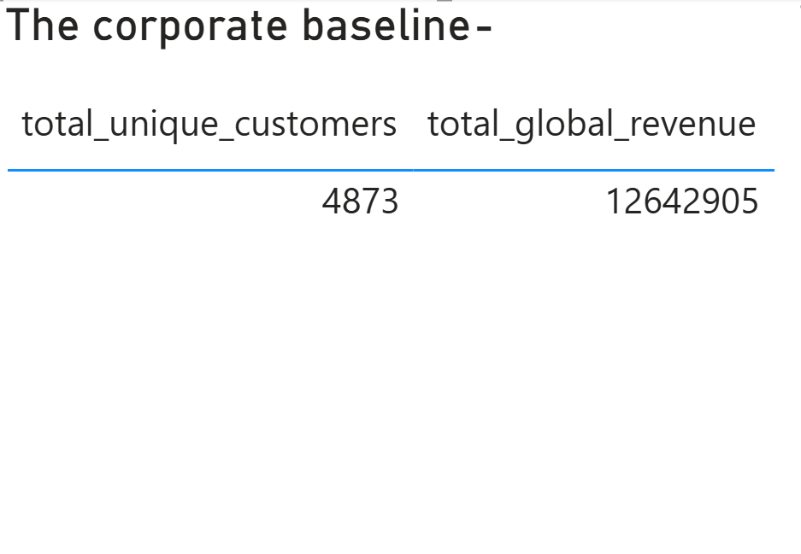
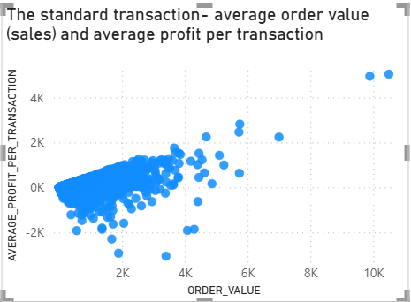

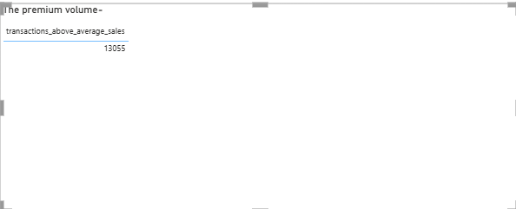

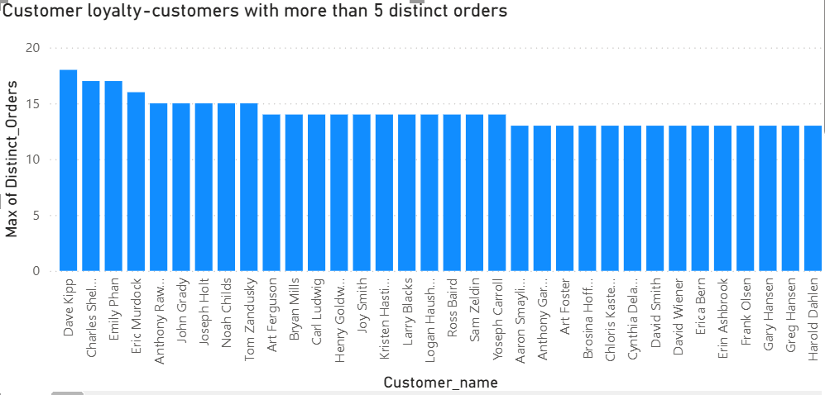

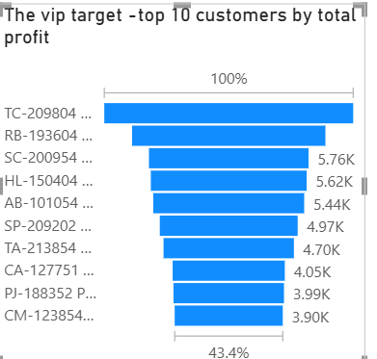

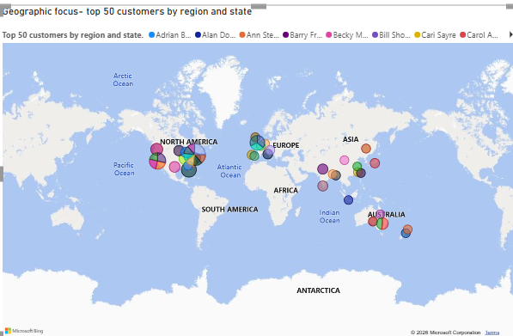

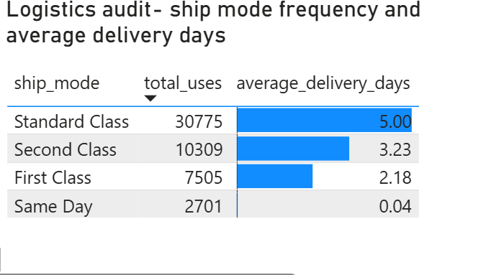

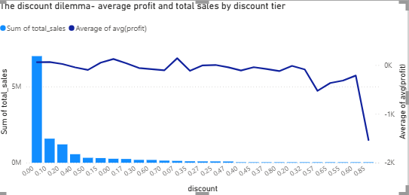

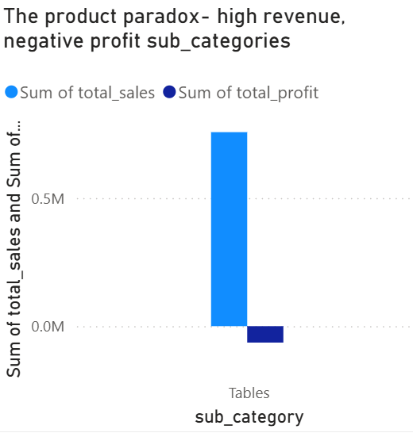

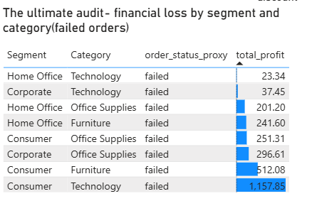

RECOMMENDATION:

- Cap discounts at 20–25%: Every discount tier at 30% or above operates at a loss on average (Q8), bottoming out at -$1,534 per order at 85% off. A hard ceiling around 20–25% is a concrete, low-risk policy change.
- Re-evaluate the Tables Sub-Category: Tables is the only Sub-Category with negative total profit (-$64,083.39) despite $757,034 in sales, and carries the highest average discount of any Sub-Category (29%). Review its pricing, sourcing cost, and discount authorization specifically (Q9).
- Enforce a Priority → Ship Mode business rule: Only 19% of Critical-priority orders currently ship Same Day. Implementing a system rule that automatically assigns fast shipping to Critical orders would close this gap without requiring a blanket, costly speed-up across all orders (Root Cause Analysis, Objective 2).
- Source a real Returns/Status table: No return or failed-delivery data exists in the current dataset. Q10 was answered using a documented shipping-delay proxy, but a genuine Status field would allow the original VP concern about returns to be tested directly rather than approximated.
- Standardize Customer ID as the canonical grouping key: Customer Name is not reliably unique (4,873 Customer IDs map to only 795 distinct names). Any future reporting, dashboards, or CRM segmentation should join and group on Customer ID, not Customer Name.
- Fix Product ID uniqueness at the source system: 457 Product IDs currently map to more than one distinct product. This was corrected for this audit via deduplication, but should be fixed at the point of data entry to prevent recurring join errors in future analyses.
Consider VIP retention outreach for top-profit customers: Tamara Chand, Raymond Buch, and Sanjit Chand each contribute over $5,700 in individual profit (Q5) — a natural starting list for a loyalty or account-management program.

CONCLUSION:
This audit set out to answer why Global Superstore's record-high revenue was not translating into proportional profit, and to give the executive team a data-backed view of their customers, products, and logistics. The evidence points to two clear, correctable causes: discount depth beyond ~20–25% reliably erases profit on an order-by-order basis, and the Tables Sub-Category — driven by that same discounting pattern — is the single product line actively losing the company money despite strong sales.
On the operations side, the shipping department's strain is best explained by a cost-driven routing choice (Standard Class) rather than a lack of capacity, since the company already demonstrates it can ship quickly for Critical orders. The customer-returns concern raised by the VP of Logistics could not be directly verified, as no Status or Returns field exists in the available data — but the shipping-delay proxy applied in Question 10 found no evidence that delayed shipments are a meaningful source of loss, reinforcing that the Tables/discount finding remains the primary driver worth acting on.
All identifier and join issues encountered along the way — a non-unique Product ID, a Customer Name field unsafe for grouping, and a Locations join prone to fan-out — were investigated, quantified with real evidence, and corrected before being used in any reported figure. The recommendations in Section 4 translate these findings into concrete next steps for Global Superstore's finance, product, and logistics teams.

APPENDIX: FULL VERIFICATION QUERIES
All queries used to identify, quantify and validate findings in this report are stated below for transparency and reproducibility.

A.1 CUSTOMER ID UNIQUENESS CHECK:
SELECT Customer_ID, COUNT(DISTINCT Customer_Name) AS name_variations
FROM customers
GROUP BY Customer_ID
HAVING COUNT(DISTINCT Customer_Name) > 1;
Result: 0 rows returned — Customer ID is fully unique
A.2 PRODUCT ID DUPLICATE DETECTION:
Identify Product IDs mapped to more than one distinct product
SELECT Product_ID, COUNT(*) AS row_count
FROM products
GROUP BY Product_ID
HAVING COUNT(*) > 1
ORDER by row_count desc;
Result: 457 Product IDs returned, 457 duplicate rows, 476 total instances.

Inspect the actual differing rows
SELECT * FROM products
WHERE Product_ID IN (SELECT Product_ID FROM products
GROUP BY Product_ID
HAVING COUNT(*) > 1)
ORDER BY Product_ID;
Result: 933 rows returned

Count order lines affected
SELECT COUNT(*) AS affected_rows
FROM orders
JOIN(SELECT Product_ID FROM products
GROUP BY Product_ID
HAVING COUNT(*) > 1) d on orders.product_id= d.product_id;
Result: 4,392 rows (8.6% of dataset)

A.3 ORDER ID REUSE DETECTION:

Order IDs reused across different customers
SELECT Order_ID, COUNT(DISTINCT Customer_ID) AS customer_variations
FROM orders
GROUP BY Order_ID
HAVING COUNT(DISTINCT Customer_ID) > 1;
Result: 659 distinct Order IDs

Order IDs reused across different order dates
SELECT Order_ID, COUNT(DISTINCT Order_Date) AS date_variations
FROM orders
GROUP BY Order_ID
HAVING COUNT(DISTINCT Order_Date) > 1;
Result: 659 distinct Order IDs

Combined total (union of both conditions)
SELECT Order_ID,
COUNT(DISTINCT Customer_ID) AS customer_variations,
COUNT(DISTINCT Order_Date) AS date_variations
FROM orders
GROUP BY Order_ID
HAVING COUNT(DISTINCT Customer_ID) > 1
OR COUNT(DISTINCT Order_Date)> 1;
Result: 660 distinct Order IDs, 717 duplicate instances

Rows affected (combined)
select *
FROM orders
JOIN (SELECT Order_ID
FROM orders
GROUP BY Order_ID
HAVING COUNT(DISTINCT Customer_ID) > 1
OR COUNT(DISTINCT Order_Date) > 1) flagged ON orders.Order_ID = flagged.Order_ID;
Result: 2,703 rows (5.3% of dataset)

A.4 CUSTOMER NAME COLLISSION CHECK:

SELECT Customer_Name, COUNT(DISTINCT Customer_ID) AS id_count
FROM customers
GROUP BY Customer_Name
HAVING COUNT(DISTINCT Customer_ID) > 1
ORDER BY id_count DESC;
Result:795 rows returned

A.5 PRODUCT_CLEAN CREATION AND VERIFICATION used for (Q9 and Q10 ONLY):

CREATE TABLE product_clean AS
SELECT Product_ID, MIN(Product_Name) AS Product_Name,
MIN(Category) AS Category, MIN(Sub_Category) AS Sub_Category
FROM products
GROUP BY Product_ID;
SELECT Product_ID, COUNT(*) FROM product_clean
GROUP BY Product_ID HAVING COUNT(*) > 1;
Result: 0 rows — deduplication confirmed successful

APPENDIX B: ROOT CAUSE ANALYSIS, OBJECTIVE 1, VALIDATION QUERIES

B.1 WHY IS PROFIT LOW DESPITE RECORDS OF SALES? DISCOUNT/PROFIT CORRELATION:

SELECT
(SUM(Discount * Profit) - SUM(Discount) * SUM(Profit) / COUNT(*))
/ (STDDEV(Discount) * STDDEV(Profit) * (COUNT(*) - 1)) AS discount_profit_correlation
FROM orders;
Result: -0.31649017182725675 — higher discounts are associated with lower profit

B.2 WHY ARE DISCOUNT SO STEEP? OVERALL AVERAGE DISCOUNT:

SELECT AVG(Discount) AS avg_discount,
MIN(Discount) AS min_discount,
MAX(Discount) AS max_discount
FROM orderS;
Result: avg = 0.14290754533047093 (14.3%), min = 0.00, max= 0.85(85%)

B.3 WHY AREN’T DISCOUNT TIED TO PROFITABILITY? AVERAGE DISCOUNT BY SUB_CATEGORY

SELECT product_clean.Sub_Category,
AVG(orders.Discount) AS avg_discount
FROM orderS
JOIN product_clean ON orders.Product_ID = product_clean.Product_ID
GROUP BY product_clean.Sub_Category
ORDER BY avg_discount DESC;
Result: Tables highest at 0.29 (29%) — roughly double the dataset average

B.4 WHY DOES THOSE SUB_CATEGORIES HAVE THIN MARGINS? SALES VS PROFIT BY SUB_CATEGORY

select product_clean.Sub_Category,
SUM(orders.Sales) AS total_sales,
SUM(orders.Profit) AS total_profit,
AVG(orders.Discount) AS avg_discount
FROM orders
JOIN product_clean ON orders.Product_ID = product_clean.Product_ID
GROUP BY product_clean.Sub_Category
ORDER BY total_profit ASC;
Result: Tables is the only Sub-Category with negative total profit
Sales = $757,034, Profit = -$64,083.39), despite strong revenue

APPENDIX C: OBJECTIVE 2 (LOGISTICS VALIDATION QUERIES)

C.1 ORDER VOLUME GROWTH BY YEAR:

SELECT Year, COUNT(DISTINCT Order_ID) AS total_orders
FROM orders
GROUP BY Year
ORDER BY Year;
Result: 2011 = 4,440 → 2014 = 8,531 (92% increase)

C.2 SHIP MODE USAGE, AVERAGE DELIVERY TIME, AVERAGE SHIPPING COST:

SELECT Ship_Mode,
COUNT(*) AS orders,
AVG(DATEDIFF(Ship_Date, Order_Date)) AS avg_delivery_days,
AVG(Shipping_Cost) AS avg_shipping_cost
FROM orders
GROUP BY Ship_Mode
ORDER BY orders DESC;
Result : Standard Class = 30,775 orders, 5.00 avg days, $19.97 avg cost
Second Class = 10,309 orders, 3.23 avg days, $30.47 avg cost
First Class = 7,505 orders, 2.18 avg days, $41.05 avg cost
Same Day = 2,701 orders, 0.04 avg days, $42.94 avg cost

C.3 ORDER PRIORITY VS ACTUAL DELIVERY TIME

SELECT Order_Priority,
COUNT(*) AS orders,
AVG(DATEDIFF(Ship_Date, Order_Date)) AS avg_delivery_days
FROM order_table
GROUP BY Order_Priority;
Result: Critical = 1.81 days, High = 3.09, Medium = 4.52, Low = 6.48

C.4 SHIP_MODE BREAKDOWN FOR CRITICAL PRIORITY ORDERS:

SELECT Ship_Mode, COUNT(*) AS orders
FROM order_table
WHERE Order_Priority = 'Critical'
GROUP BY Ship_Mode
ORDER BY orders DESC;
Result: First Class = 1,734 | Second Class = 1,456 | Same Day = 742
Only 19% of Critical orders (742 / 3,932) used the fastest available mode

APPENDIX D: LOCATIONS JOIN VALIDATING ORDERS

D.1 THE ORIGINAL FLAWED QUERY JOIN ON STATE ALONE:

SELECT customers.customer_id, customers.customer_name,
locations.state, locations.region, SUM(sales) AS total_sales
FROM orders
JOIN customers ON customers.customer_id = orders.customer_id
JOIN locations ON locations.state = orders.state
GROUP BY customers.customer_id, customers.customer_name,
locations.state, locations.region
ORDER BY total_sales DESC
LIMIT 50;
Result: James Galang returned total_sales = $1,195,427 — invalid,
caused by join fan-out (see D.2)

D.2 DIAGONIZING THE FAN-OUT, CITIES PER STATE IN LOCATIONS:

SELECT State, COUNT(DISTINCT City) AS city_count
FROM locations
GROUP BY State
ORDER BY city_count DESC;
Result: 'England' alone spans 149 distinct cities — confirming the
Locations table is city-level, causing the fan-out when joined on
State alone (no City/Country/Location ID available in Orders)

D.3 DEDUPLICATING LOCATIONS(THE FIX):

CREATE TABLE locations_clean AS
SELECT State, MIN(Region) AS Region
FROM locations
GROUP BY State;
Result: 1,093 rows created
SELECT State, COUNT(*)
FROM locations_clean
GROUP BY State
HAVING COUNT(*) > 1;
Result: 0 rows — confirmed one row per State

D.4 CONFIRMING THE CASE SENSITIVITY MERGE(1093 VS 1094):

SELECT COUNT(DISTINCT BINARY State) AS total_distinct_states
FROM orders;
Result: 1,094 — confirms the 1-row gap in locations_clean is a case-sensitivity merge (e.g., differing capitalization of one State value), not a missing row. Does not affect Sales aggregation, since MySQL's default join matching is also case-insensitive.

D.5 CORRECTED QUERY USING LOCATION_CLEAN:

SELECT customers.Customer_ID, customers.Customer_Name, locations_clean.State, locations_clean.Region, SUM(Sales) AS total_sales
FROM orders
JOIN customers ON customers.customer_id = orders.customer_id
JOIN locations_clean ON locations_clean.State = orders.State
GROUP BY customers.Customer_ID, customers.Customer_Name, locations_clean.State, locations_clean.Region
ORDER BY total_sales DESC
LIMIT 50;
Result: Top spender is Sean Miller (SM-203204, Florida, South)
at $23,660 — a realistic, verified figure

